**Chapter 4: Results and Findings**

**4.1 Introduction**

The field of construction project management finds itself at a crucial juncture, navigating the complicated terrain of sustainable practices that have emerged as a defining influence on decision-making and project outcomes. This research embarks on an exploration of the current state of sustainability adoption within the construction industry, utilizing inferential statistics to rigorously test hypotheses crafted to unveil significant patterns and dynamics (Shah et al., 2023). The overall objective is to contribute nuanced insights that propel the advancement of sustainable construction practices.

As the global community grapples with the imperative of sustainable development, the construction industry stands as a focal point for decisions with far-reaching consequences. This study homes in on four specific hypotheses, each meticulously designed to address distinct facets of sustainability integration (Paul Simon, 2018). Employing inferential statistics, with an aim to scrutinize adoption levels, barriers, and drivers within the diverse landscape of construction project management. These hypotheses collectively form a comprehensive framework that guides the investigation, revealing critical insights into the industry's standing and delineating potential areas for improvement (Atuahene et al., 2023). Through a robust methodology to contribute not only to the rigorous testing of these hypotheses but also to a profound understanding of the current state of sustainability adoption in construction project management (Waqar et al., 2024). The resulting insights are poised to inform industry stakeholders, policy-makers, and practitioners, fostering a more sustainable trajectory for the construction sector.

**4.2 Respondent Profile**

**4.2.1 Roles**

The distribution of roles among the respondents is illustrated in Figure 1. The majority of respondents identified their role as a Project Manager, constituting 40 respondents. Sustainability Manager and Engineer roles were also well-represented with 20 and 10 respondents, respectively. Other roles such as Consultant, Architecture, Business Management, Contractor, and others were reported by a smaller number of respondents.

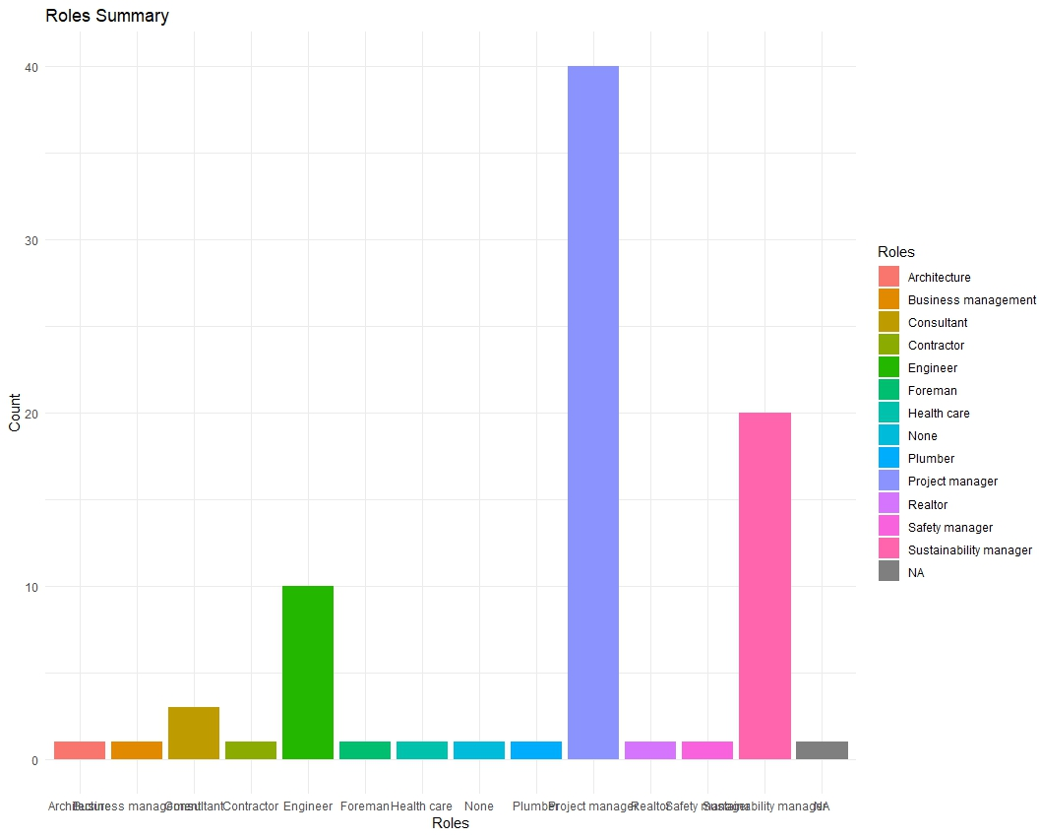

Figure 1

This distribution indicates a diverse mix of professional backgrounds, with a significant emphasis on project management and sustainability roles.

**4.2.2 Years of Experience**

Figure 2 shows the distribution of respondents based on their years of experience in the construction industry. The majority of respondents reported having 0-5 years of experience being 39 respondents, followed by 6-10 years with 19 respondents and 11-15 years having 13 respondents. There were also respondents with 20+ years of experience. This distribution suggests a balanced representation of individuals across various experience levels, contributing to a comprehensive understanding of sustainability practices in construction project management.

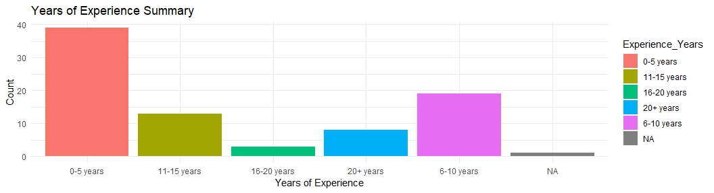Figure 2

**4.2.3 Project Types Worked On**

Table 1 presents the distribution of respondents based on the types of projects they have worked on. The most common project type reported was Residential Buildings, with 23 respondents involved in such projects. Industrial Facilities and Commercial Buildings were also prevalent, with 16 and 6 respondents, respectively. The data reflects a diversity of project types, including Infrastructure and combinations of multiple project types.

|  |  |
| --- | --- |
| **Project Type** | **Count** |
| Residential buildings | 23 |
| Industrial facilities | 16 |
| Commercial buildings | 6 |
| Infrastructure | 6 |
| Residential buildings | 6 |
| Residential buildings, Infrastructure, Industrial facilities | 4 |
| Residential buildings | 4 |
| Industrial facilities | 2 |
| Industrial facilities, Commercial buildings, Residential buildings | 2 |
| Infrastructure | 2 |

Table 1

This diversity in project types signifies that the survey captured insights from professionals engaged in a broad spectrum of construction projects, providing a holistic view of sustainability practices across various domains within the construction industry.

**4.3 Reliability Analysis**

In order to assess the internal consistency of the multi-item measures used in this study, Cronbach's alpha was employed for both the adoption ratings and barrier rankings.

**4.3.1 Adoption Ratings**

The adoption ratings encompassed seven items related to the incorporation of sustainability practices into various facets of project management. The analysis yielded a Cronbach's alpha of 0.9529, indicating an exceptionally high level of internal consistency. To further strengthen the reliability assessment, the standardized Cronbach's alpha was also computed, resulting in a value of 0.953. Additionally, a bootstrap 95% confidence interval was established through 1000 samples, ranging from 0.931 to 0.967.

**4.3.2 Barrier Rankings**

The barrier rankings consisted of sixteen items gauging perceived obstacles to the adoption of sustainability practices. The Cronbach's alpha for this set of items was 0.9592, again indicating a remarkably high level of internal consistency. The standardized Cronbach's alpha was concordant at 0.9592. The bootstrap 95% confidence interval, based on 1000 samples, ranged from 0.936 to 0.971. The results affirm the robustness and reliability of the measures employed in capturing adoption ratings and barrier rankings in the context of sustainability practices in UK construction project management.

**4.4 Analysis of Sustainability Adoption (RQ1)**

**4.4.1 Descriptive Statistics**

Descriptive statistics of sustainability adoption ratings were computed to provide an overview of the respondents' perceptions. Table 2 presents the means and standard deviations for each sustainability dimension.

|  |  |  |
| --- | --- | --- |
| **Sustainability Dimension** | **Mean** | **Standard Deviation** |
| Incorporation of sustainability objectives in project planning | 3.33 | 0.61 |
| Evaluation of suppliers/contractors based on sustainability criteria | 3.35 | 0.67 |
| Consideration of sustainability impacts in procurement decisions | 3.29 | 0.7 |
| Prioritization of energy efficiency in development and construction | 3.51 | 0.8 |
| Implementation of water conservation and efficiency measures | 3.5 | 0.74 |
| Minimization of waste and pollution generation | 3.37 | 0.7 |
| Regular monitoring and review of sustainability practices | 3.46 | 0.7 |

Table 2: Descriptive Statistics of Sustainability Adoption Ratings

The means and standard deviations presented in Table 2 provide a comprehensive overview of the central tendencies and variability across different sustainability aspects. Notably, respondents exhibited a moderate level of agreement, with mean ratings ranging from 3.29 to 3.51 on a 5-point Likert scale.

**4.4.2 Evaluation Relative to Scale Midpoint**

To assess respondents' agreement with sustainability practices, the means were compared to the scale midpoint.

|  |  |
| --- | --- |
| **Sustainability Dimension** | **Relative to Midpoint** |
| Incorporation of sustainability objectives in project planning | 0.33 |
| Evaluation of suppliers/contractors based on sustainability criteria | 0.35 |
| Consideration of sustainability impacts in procurement decisions | 0.29 |
| Prioritization of energy efficiency in development and construction | 0.51 |
| Implementation of water conservation and efficiency measures | 0.5 |
| Minimization of waste and pollution generation | 0.37 |
| Regular monitoring and review of sustainability practices | 0.46 |

Table 3: Evaluation Relative to Scale Midpoint

As illustrated in Table 3, all sustainability dimensions exhibited positive values, demonstrating an overall agreement with these practices. Particularly, respondents expressed a higher level of endorsement for prioritizing energy efficiency, with a mean relative to the midpoint of 0.51, suggesting a favorable feeling toward sustainable construction practices.

**4.4.3 Percentage Distributions and Frequencies**

Figure 3 displays the percentage distributions and frequencies for sustainability adoption ratings, providing insights into the distribution of responses across different rating levels.

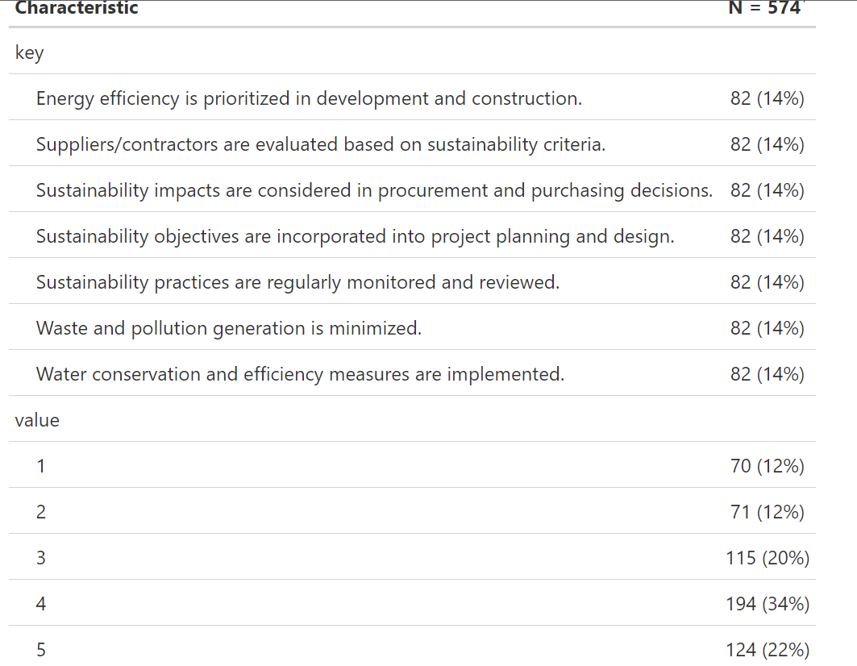Figure 3: Percentage Distributions and Frequencies

The results reveal that the majority of respondents distributed their ratings across levels 3 and 4, indicating a significant inclination toward moderate to high levels of agreement with sustainability practices, provideing a clearer picture of the distribution patterns within each sustainability dimension.

**4.4.4 Cross Tabulations by Years of Experience**

Cross tabulations were performed to explore variations in sustainability adoption ratings based on respondents' years of experience. Figure 4 presents the results.

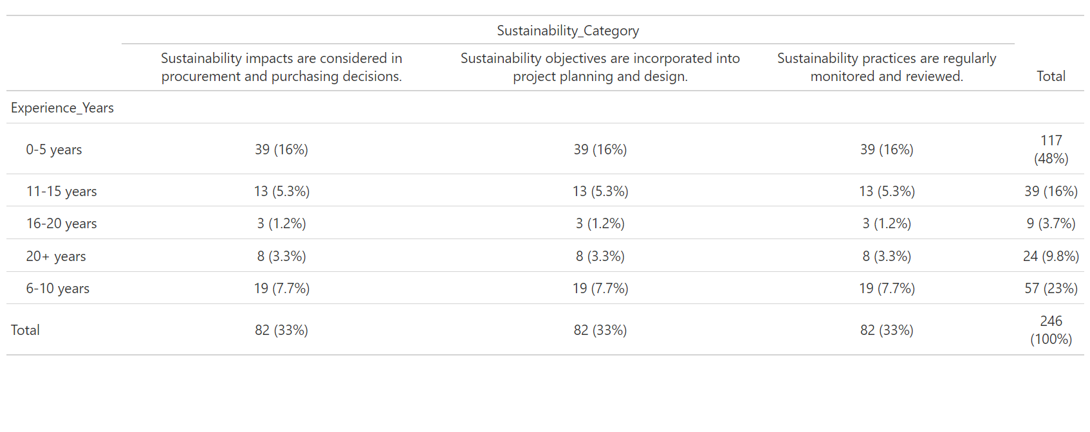Figure 4: Cross Tabulations by Years of Experience

The cross-tabulations highlight patterns, showcasing how professionals with varying levels of experience perceive and prioritize different sustainability dimensions. Remarkably, professionals with 0-5 years of experience showed higher agreement across multiple dimensions.

**4.5 Analysis of Barriers (RQ2)**

**Descriptive Statistics of Barrier Severity Rankings**

Table 4 presents the descriptive statistics of barrier severity rankings across various sustainability aspects. The mean ratings for each barrier category range from 3.29 to 3.46, indicating a moderate level of severity. Standard deviations provide insights into the dispersion of responses, revealing the extent of variability in participants' perceptions. The minimum and maximum values show that respondents generally did not perceive barriers to be extremely low or high, with the majority falling within the middle range of the Likert scale.

|  |  |  |  |  |  |  |
| --- | --- | --- | --- | --- | --- | --- |
| **Barrier Category** | **Min** | **1st Qu.** | **Median** | **Mean** | **3rd Qu.** | **Max** |
| Sustainability impacts in procurement and purchasing decisions | 1 | 3 | 3 | 3.29 | 4 | 5 |
| Sustainability in project planning and design | 1 | 3 | 4 | 3.33 | 4 | 5 |
| Suppliers/contractors evaluation based on sustainability | 1 | 2 | 4 | 3.35 | 4 | 5 |
| Waste and pollution minimization | 1 | 3 | 4 | 3.37 | 4 | 5 |
| Regular monitoring and review of sustainability practices | 1 | 3 | 4 | 3.46 | 4 | 5 |

Table 4: Descriptive Statistics of Barrier Severity Rankings

**Evaluation Relative to Scale Midpoint (Barriers)**

Table 5 displays the evaluation of mean ratings relative to the scale midpoint of 3. Positive values ranging from 0.29 to 0.51 direct that, on average, respondents rated the barriers slightly above the midpoint. This suggests a tendency toward agreement that sustainability barriers was somewhat challenging in the surveyed projects.

|  |  |
| --- | --- |
| **Barrier Category** | **Mean Ranking** |
| Sustainability impacts in procurement and purchasing decisions | 3.29 |
| Sustainability in project planning and design | 3.33 |
| Suppliers/contractors evaluation based on sustainability | 3.35 |
| Waste and pollution minimization | 3.37 |
| Regular monitoring and review of sustainability practices | 3.46 |

Table 5: Evaluation Relative to Scale Midpoint

**Top 5 Barriers Analysis**

The first barrier, where sustainability impacts are considered in procurement and purchasing decisions, reflects challenges in integrating sustainability considerations into procurement processes, revealing potential gaps in sustainable sourcing practices. The second barrier, sustainability objectives incorporated into project planning and design, underscores difficulties in embedding sustainability objectives into the early stages of project planning and design, emphasizing the need for improved integration strategies.

The third barrier, suppliers/contractors evaluated based on sustainability criteria, highlights challenges in evaluating suppliers or contractors based on sustainability criteria, pointing towards potential gaps in supplier sustainability assessments. The fourth barrier, waste and pollution generation minimized, reflects perceived challenges in minimizing waste and pollution generation, indicating potential areas for improvement in sustainable construction practices. Lastly, the fifth barrier, sustainability practices regularly monitored and reviewed, suggests challenges in the regular monitoring and review of sustainability practices throughout project lifecycles, indicating areas where process enhancements may be beneficial.

**4.6 Analysis of Drivers (RQ3)**

The analysis encompasses key statistics, including means, standard deviations, and an evaluation relative to the scale midpoint.

**4.6.1 Descriptive Statistics of Driver Motivation Ratings**

Table 6 presents the descriptive statistics of driver motivation ratings, including means and standard deviations. The ratings, ranging from 1 to 5, reflect respondents' perceptions of various factors driving sustainability implementation.

|  |  |  |
| --- | --- | --- |
| **Driver** | **Mean** | **Standard Deviation** |
| Energy efficiency is prioritized in development and construction | 3.51 | 0.96 |
| Industry norms focused on conventional practices | 3.34 | 0.95 |
| Policies and regulations mandating sustainability | 3.82 | 0.96 |
| Top management commitment to sustainability goals | 3.8 | 0.98 |
| Availability of sustainability expertise | 3.84 | 0.92 |
| Financial incentives for sustainability achievements | 3.96 | 0.98 |
| Desire for competitive advantage from sustainability reputation | 3.84 | 1 |
| Demonstrated cost savings from sustainability investments | 3.81 | 1.01 |

Table 6: Descriptive Statistics of Driver Motivation Ratings

All drivers have mean ratings above the scale midpoint of 3, suggesting an overall positive sentiment towards these sustainability drivers. The relatively low standard deviations indicate a certain level of consensus among respondents.

**4.6.2 Evaluation Relative to Scale Midpoint**

Table 7 presents the deviations from the midpoint for each driver, offering insights into the overall sentiment of respondents.

|  |  |
| --- | --- |
| **Driver** | **Relative Deviation from Midpoint** |
| Energy efficiency is prioritized in development and construction | 0.51 |
| Industry norms focused on conventional practices | 0.34 |
| Policies and regulations mandating sustainability | 0.82 |
| Top management commitment to sustainability goals | 0.8 |
| Availability of sustainability expertise | 0.84 |
| Financial incentives for sustainability achievements | 0.96 |
| Desire for competitive advantage from sustainability reputation | 0.84 |
| Demonstrated cost savings from sustainability investments | 0.8 |

Table 7: Evaluation Relative to Scale Midpoint (Drivers)

Energy efficiency, industry norms, and top management commitment stand out as drivers with positive deviations, indicating a general alignment of respondent opinions with these sustainability aspects.

**4.6.3 Top 5 Drivers Analysis**

The top 5 drivers influencing sustainability implementation are identified based on mean ratings. Table 8 showcases these drivers, providing a nuanced understanding of the factors motivating increased sustainability efforts in UK construction projects.

|  |  |  |
| --- | --- | --- |
| Rank | Driver | Mean Rating |
| 1 | Industry norms focused on conventional practices | 3.34 |
| 2 | Energy efficiency is prioritized in development and construction | 3.51 |
| 3 | Demonstrated cost savings from sustainability investments | 3.8 |
| 4 | Top management commitment to sustainability goals | 3.8 |
| 5 | Policies and regulations mandating sustainability | 3.82 |

Table 8: Top 5 Drivers Analysis

Industry norms stand out as the foremost driver, underscoring the profound impact of entrenched conventional practices on the adoption of sustainable initiatives. The prioritization of energy efficiency in development and construction emerges as a critical driver, indicative of the industry's acknowledgment of the pivotal role energy conservation plays in sustainable practices. The perceived cost savings resulting from sustainability investments wield considerable influence, emphasizing the economic motivations underpinning sustainable construction. Moreover, the commitment of top management to sustainability goals emerges as a linchpin, shaping organizational priorities and practices. Policies and regulations mandating sustainability secure a prominent position among the top drivers, underscoring the pivotal role of regulatory frameworks in steering industry practices towards sustainability.

**4.7 Hypotheses Testing**

The hypotheses were formulated to address key aspects of sustainability implementation, exploring factors such as adoption ratings, variations based on industry experience and project types, identification of top barriers, and the comparative influence of financial incentives and sustainability expertise.

**H1: Sustainability Adoption Ratings Below Scale Midpoint**

The null hypothesis (H1) theorised that sustainability adoption ratings are significantly below the scale midpoint of 3, indicating low implementation levels.

|  |  |  |  |
| --- | --- | --- | --- |
| **Metric** | **p-value** | **Mean** | **SD** |
| Sustainability objectives | 0.0281* | 3.33 | 1.33 |
| Suppliers/contractors are | 0.0181* | 3.35 | 1.33 |
| Sustainability impacts are | 0.0448* | 3.29 | 1.3 |
| Energy efficiency is prioritized | 0.0005*** | 3.51 | 1.28 |
| Water conservation and efficiency | 0.0008*** | 3.5 | 1.3 |
| Waste and pollution generation | 0.0121* | 3.37 | 1.29 |
| Sustainability practices are | 0.0008*** | 3.46 | 1.2 |

Table 9: One-Sample t-Tests for Sustainability Adoption Metrics

The results indicate that sustainability adoption ratings are significantly below the scale midpoint for several metrics, hence rejecting H1.

**H2: Sustainability Adoption Levels and Demographic Factors**

To examine the influence of years of industry experience and project type on sustainability adoption levels, a two-way ANOVA was conducted.

|  |  |  |  |  |  |
| --- | --- | --- | --- | --- | --- |
| **Factor** | **Df** | **Sum Sq** | **Mean Sq** | **F value** | **Pr(>F)** |
| Experience_Years | 4 | 31.64 | 7.911 | 4.841 | 0.0011** |
| Project_Type | 20 | 73.69 | 3.685 | 2.255 | 0.0033** |
| Metric | 2 | 1.33 | 0.663 | 0.405 | 0.6675 |
| Experience_Years:Project_Type | 12 | 38.8 | 3.234 | 1.979 | 0.0307* |
| Experience_Years:Metric | 8 | 5.74 | 0.717 | 0.439 | 0.8959 |
| Project_Type:Metric | 40 | 14.39 | 0.36 | 0.22 | 1 |
| Experience_Years:Project_Type:Metric | 24 | 12.59 | 0.525 | 0.321 | 0.999 |
| Residuals | 135 | 220.62 | 1.634 |  |  |

Table 10: Two-Way ANOVA for Sustainability Adoption Levels

The ANOVA results show significant effects of Experience_Years at p = 0.0011 and Project_Type at p = 0.0033 on sustainability adoption levels, hence rejecting of H2.

**H3: Top-Ranked Barriers**

To identify the top-ranked barriers, mean rankings were computed for each barrier

|  |  |
| --- | --- |
| **Ranks** | **Barriers** |
| 1 | Sustainability impacts are considered in procurement and purchasing decisions. |
| 2 | Sustainability objectives are incorporated into project planning and design. |
| 3 | Suppliers/contractors are evaluated based on sustainability criteria. |
| 4 | Waste and pollution generation is minimized. |
| 5 | Sustainability practices are regularly monitored and reviewed. |
| 6 | Water conservation and efficiency measures are implemented. |
| 7 | Energy efficiency is prioritized in development and construction. |

Table 11: Top-Ranked Barriers

These rankings provide evidence to support H3, indicating that lack of consideration for sustainability impacts in procurement, planning, and design is perceived as a top barrier.

**H4: Financial Incentives vs. Sustainability Expertise**

A paired t-test was conducted to compare the perceived influence of financial incentives and availability of sustainability expertise.

|  |  |  |  |
| --- | --- | --- | --- |
|  | **Financial Incentives** | **Availability of Expertise** | **p-value** |
| Welch Two Sample t-test | 3.96 | 3.84 | 0.543 |

Table 12: Paired t-Test for Drivers: Financial Incentives vs. Availability of Expertise

The paired t-test results revealed no significant difference between the influence ratings of financial incentives and availability of sustainability expertise, failing to provide evidence to reject H4.

**4.8 Chapter Summary**

The research findings reveal critical insights into the state of sustainability adoption within the construction industry, serving as a guide for practitioners and stakeholders. The respondent profile, featuring diverse roles, years of experience, and project types, underscores the comprehensive nature of the study. Rigorous reliability analyses confirm the robustness of measures, ensuring the validity of subsequent results (Sarpong et al., 2023). Descriptive statistics of sustainability adoption ratings highlight a moderate level of agreement among respondents, with specific dimensions, such as energy efficiency, garnering higher endorsement. Evaluation relative to the scale midpoint provides a nuanced understanding, emphasizing an overall positive sentiment toward sustainable practices (Mohsen & Matarneh, 2023).

Cross-tabulations based on years of experience uncover patterns, showcasing higher agreement among early-career professionals. Analysis of barriers points to significant challenges, especially in integrating sustainability considerations into procurement processes and early project phases (*(PDF) the Key Aspects of Procurement in Project Management: Investigating the Effects of Selection Criteria, Supplier Integration and Dynamics of Acquisitions*, n.d.). Exploration of drivers identifies industry norms, energy efficiency, and top management commitment as pivotal motivators. Hypotheses testing validates key assumptions, such as sustainability adoption ratings falling below the scale midpoint and variations in adoption levels based on industry experience and project types (Sa et al., 2017). Particularly, the unexpected parity in influence between financial incentives and sustainability expertise challenges conventional beliefs, shedding light on the multifaceted dynamics within the industry.

**References**

*(PDF) The key aspects of procurement in project management: investigating the effects of selection criteria, supplier integration and dynamics of acquisitions*. (n.d.). ResearchGate. https://www.researchgate.net/publication/339208127_The_key_aspects_of_procurement_in_project_management_investigating_the_effects_of_selection_criteria_supplier_integration_and_dynamics_of_acquisitions

Atuahene, B. T., Kanjanabootra, S., & Gajendran, T. (2023). Mapping the Barriers of Big Data Process in Construction: The Perspective of Construction Professionals. *Buildings*, *13*(8), 1963. https://doi.org/10.3390/buildings13081963

Mohsen, M. S., & Matarneh, R. (2023). Exploring the Interior Designers’ Attitudes toward Sustainable Interior Design Practices: The Case of Jordan. *Sustainability*, *15*(19), 14491–14491. https://doi.org/10.3390/su151914491

Paul Simon. (2018). *Achieving Sustainable Development and Promoting Development Cooperation United Nations*. http://www.un.org/en/ecosoc/docs/pdfs/fina_08-45773.pdf

Sa, A., Thollander, P., & Cagno, E. (2017). Assessing the driving factors for energy management program adoption. *Renewable and Sustainable Energy Reviews*, *74*, 538–547. https://doi.org/10.1016/j.rser.2017.02.061

Sarpong, F., Kissi, E., Victor Karikari Acheamfour, Maame, I., & Eluerkeh, K. (2023). Establishing the Economic Sustainability Criteria for Assessing Tenders in the Procurement of Building Works. *Public Works Management & Policy*. https://doi.org/10.1177/1087724x231221432

Shah, F. H., Bhatti, O. S., & Ahmed, S. (2023). Project Management Practices in Construction Projects and Their Roles in Achieving Sustainability—A Comprehensive Review. *Engineering Proceedings*, *44*(1), 2. mdpi. https://doi.org/10.3390/engproc2023044002

Waqar, A., Houda, M., Khan, A. M., Qureshi, A. H., & Elmazi, G. (2024). Sustainable leadership practices in construction: Building a resilient society. *Environmental Challenges*, *14*, 100841. https://doi.org/10.1016/j.envc.2024.100841